Fun & Games
Part A

I created this book as part of my Gold Award Project. This is the highest award a girl scouts may earn. I thought dementia, and Alzheimer’s were important disease that many people do not know the effects of. Through my research I have found there are many different styles of this disease but they range in various stages, or symptoms. This activity booklet is to help prevent or postpone the major stages by keeping one’s mind active. Hopefully you will enjoy it!
Can be diagonal, across, horizontal and backwards

Sports

TENNIS HOCKEY TRACK
BASKETBALL BASEBALL. POLO
SOCCER SOFTBALL. SWIM
FOOTBALL DANCE
LACROSSE CHEERLEADING
SKI RUGBY

G T E B W JS K Y K I S R K S K I T Y G R F J K S P O L Y B G U R E J L O A S W I T H J I A Q W H C Z X K G D A N F E R P H H S I I L D I J K B I K K I A L D Y Z S K D H I I IH Q A C V B K L J G I E S
C H E Y L D A N C E R I G K J O L L H G Q I H R S Y E H K H B S
H O H O K O J K L W E W J I K C R K C T B A S E B A L L I D K R
E L A C N Z P H K F K D J J S D I O K Q K R U S I S K W T U V B I
E I L P H J O H K K O L B V W H Y U P L A C A S H M L K H A U
R H L Y T L H K G I F I A Q H N U L A T H J J E C N K D K F J I Y
L A C R O S S E G J D K T G O J J O L S T D C I H K U I D B H B B
E G J S C I O G J D J F N I J F L T A B E R V I J I K P O L A N B Q A
A T U D F C N M O P Q R S T U V B X W Y Z J I K S K J O L P N S
D R J I J K C N O E Y M A H I J B F O O T B A L L J I Z C N K O K
I W C V E E C B A S H J K K I K H F B J E I S D I V C S A Q W L E
N E V J I I R H J D I H J O P N B S A H K N I I I O L K JIN O P H S T G W A S A T T S W A R A U T F G R T L N Y S Q R T U O P R B I B G I S A S D F G Y T R E W Q Z X C I K H I U H K L M N B V C X A U K G O C Y F V H U T Z T Y K U F C G S G S U J K X Y U P L I L G T S O F T B A L L H S I K S T U F S D C I L H G T R S T E I V I L

Cross word – zoo animals
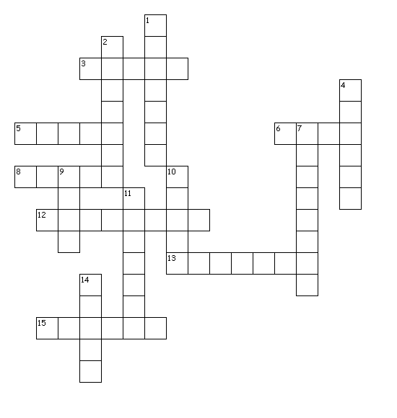
Across
3. Bear lives in Antarctica
5. Has humps
6. Backyard animals
8. Looks like a horse
12. Pink bird
13. Wears a mask
15. Animals that climb trees

Down
1. Has colorful feathers
2. In the monkey family
4. It has a hard shell
7. Also a circus animal
9. Eagle United States national bird
10. Orange cat
11. As long neck
14. Eat bamboo

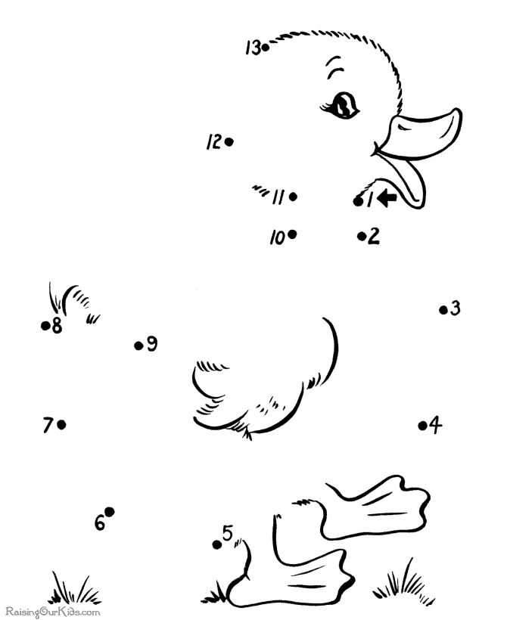

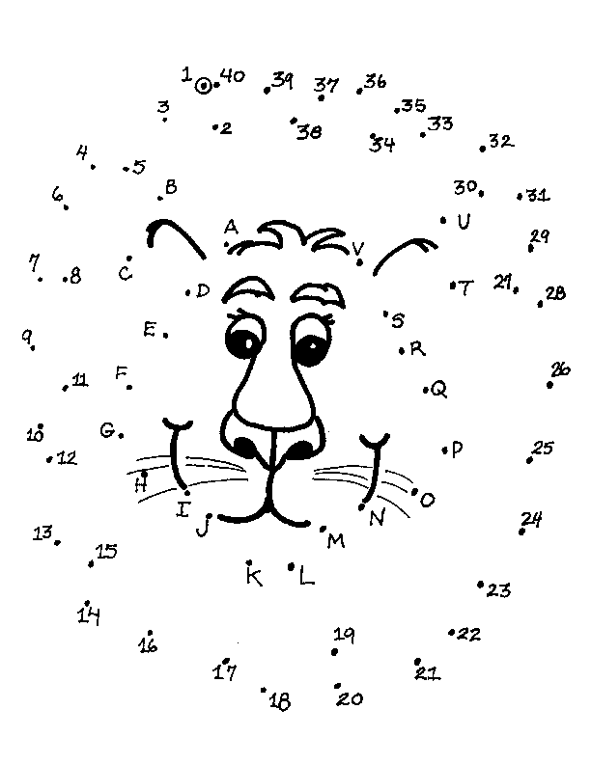

Help me find the way out!
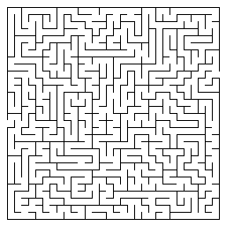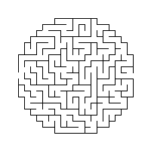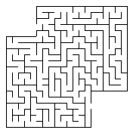

Tic Tac Toes boards

Color in the pictures
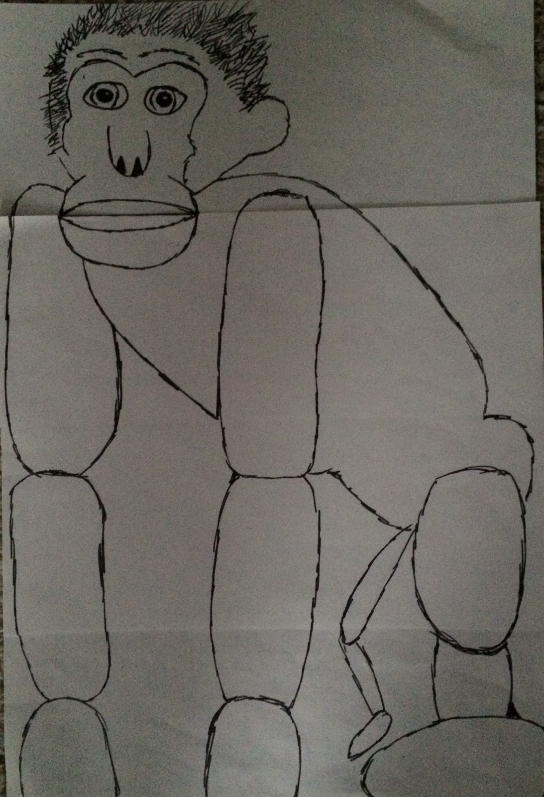
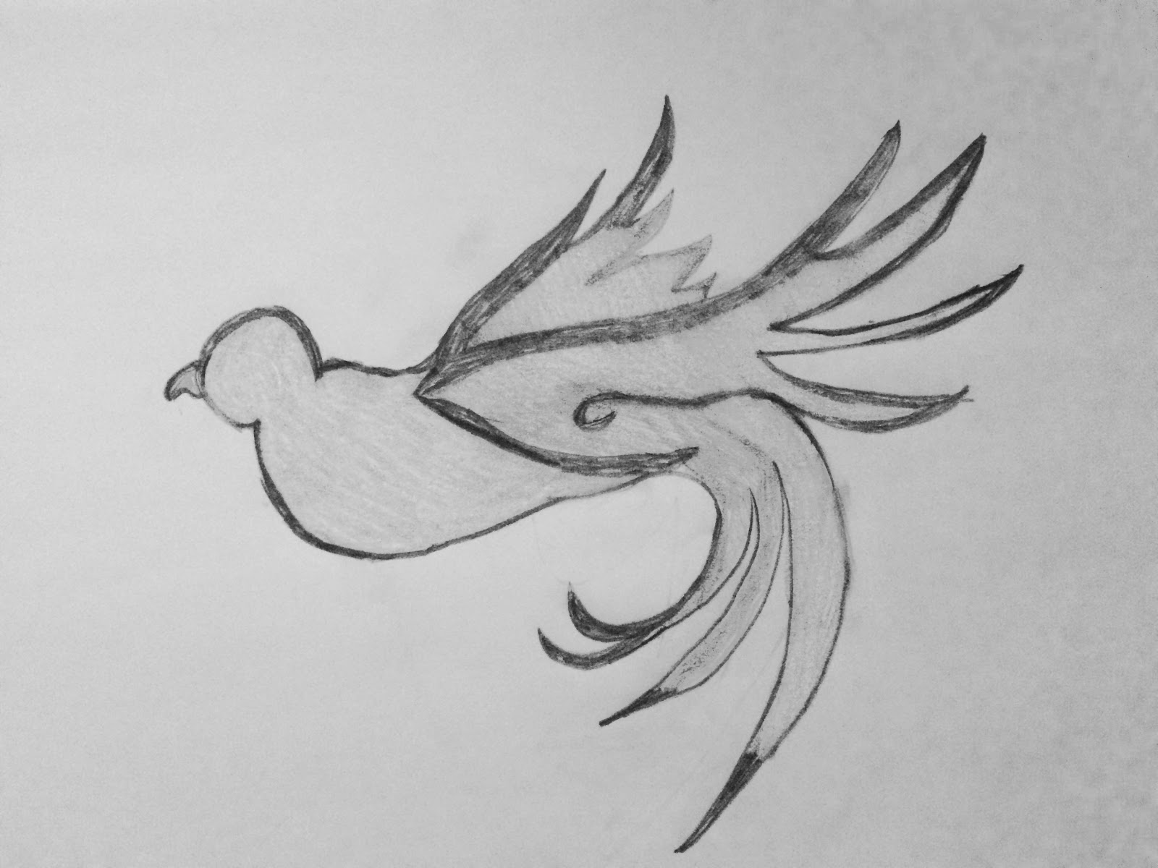
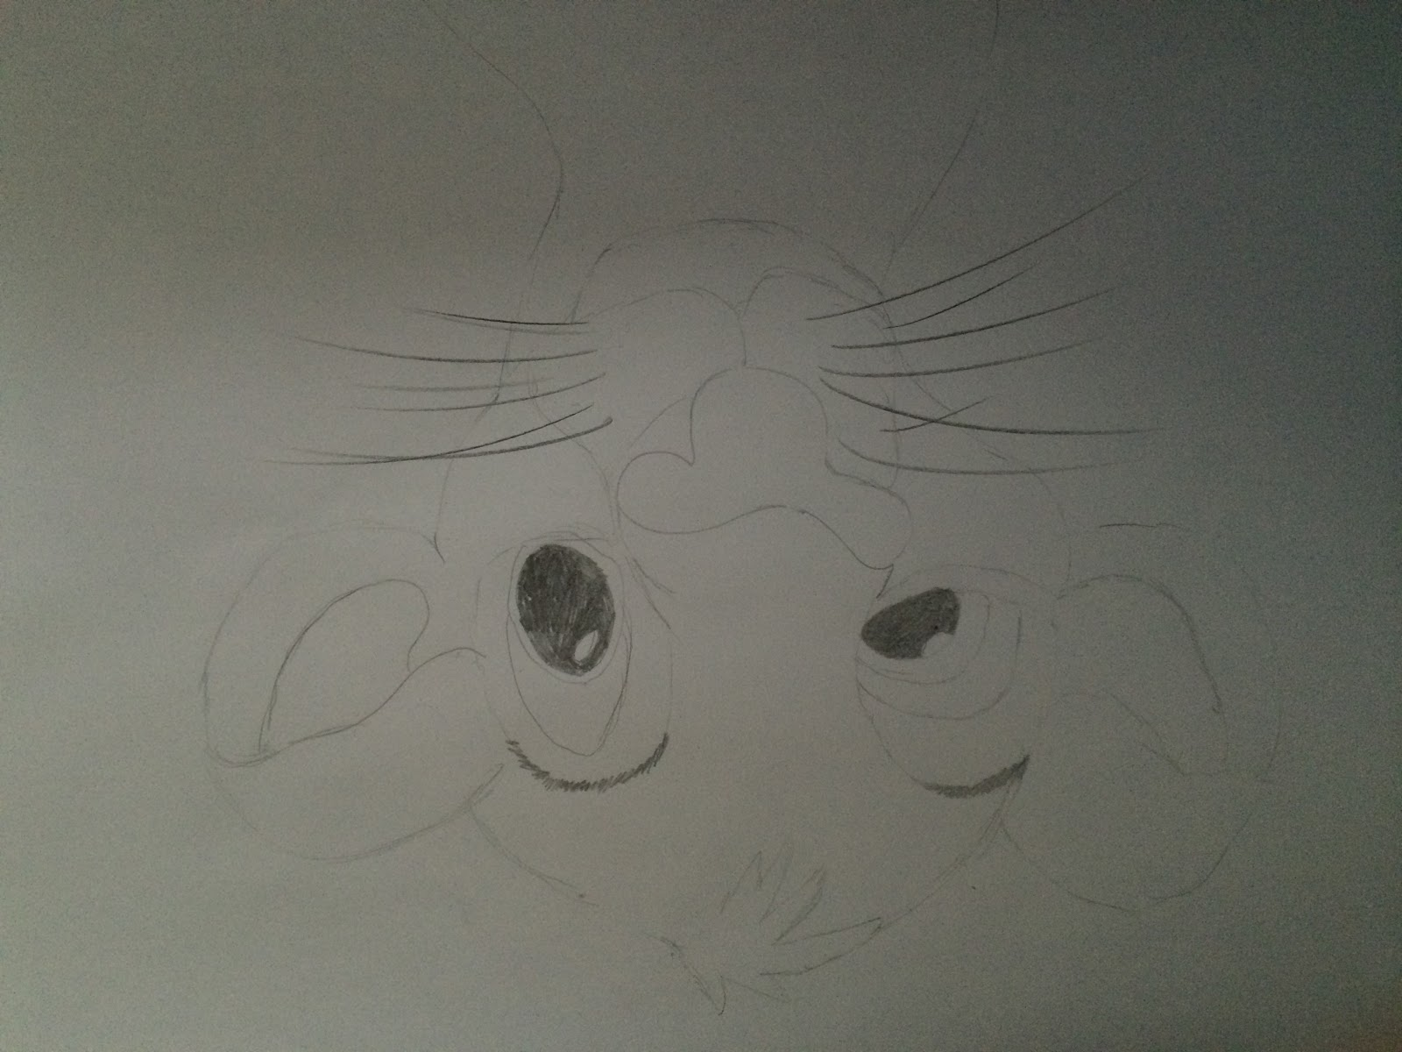
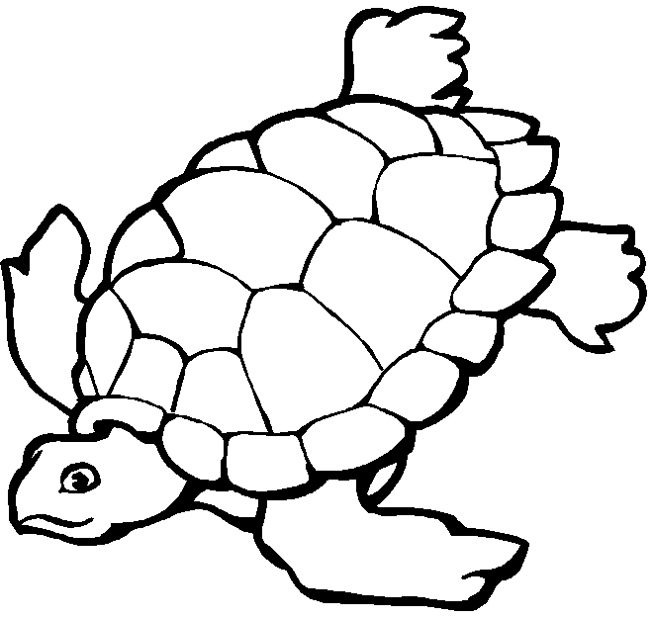

Line and Dot Game
Directions - This is a game for two or more people.
1. Start the game. Take turns drawing horizontal or vertical lines between adjacent dots connecting them together.
2. If you complete a full square, write your initial in the box and take another turn. If your line creates two boxes, then you get to put your initial in both of them. Some strategy will be involved to see if you can create more boxes than your opponent.
3. Continue playing until all the dots on the page are connected.
4. Count how many boxes each player has on the page. The player with the most boxes wins!
Here is an example of a game:
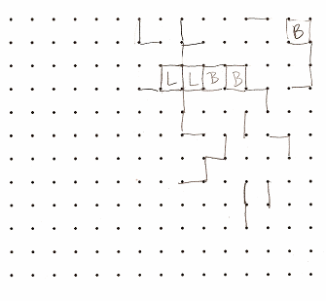

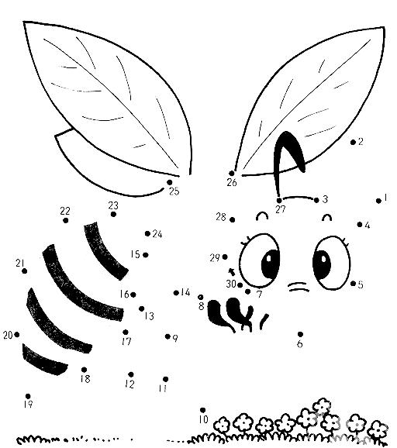

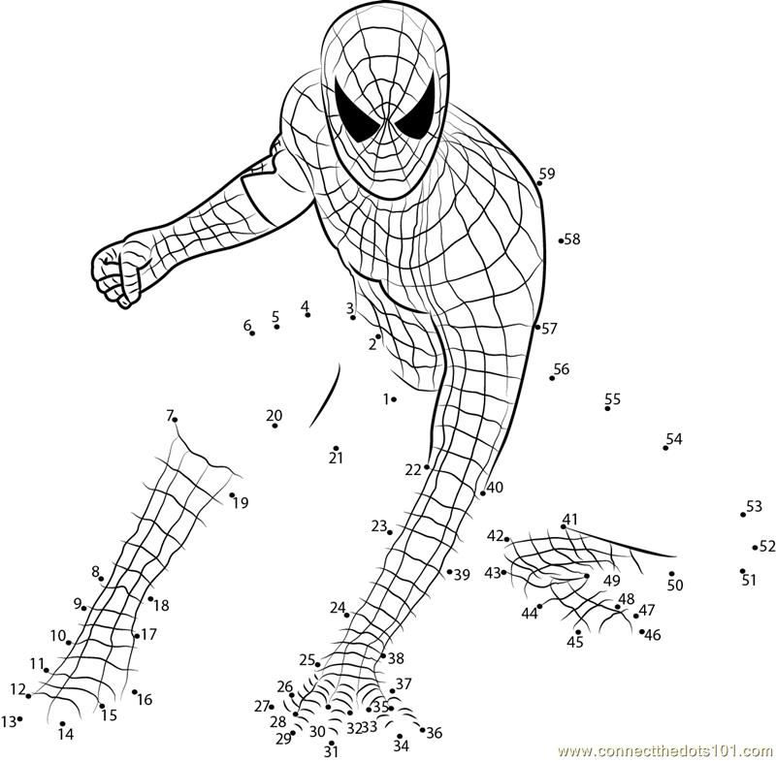

Solutions
Sports
G T E B W JS K Y K I S R K S K I T Y G R F J K S P O L Y B G U R
E J L O A S W I T H J I A Q W H C Z X K G D A N F E R P H H S I I
L D I J K B I K K I A L D Y Z S K D H I I IH Q A C V B K L J G I E S
C H E Y L D A N C E R I G K J O L L H G Q I H R S Y E H K H B S
H O H O K O J K L W E W J I K C R K C T B A S E B A L L I D K R
E L A C N Z P H K F K D J J S D I O K Q K R U S I S K W T U V B I
E I L P H J O H K K O L B V W H Y U P L A C A S H M L K H A U
R H L Y T L H K G I F I A Q H N U L A T H J J E C N K D K F J I Y
L A C R O S S E G J D K T G O J J O L S T D C I H K U I D B H B B
E G J S C I O G J D J F N I J F L T A B E R V I J I K P O L A N B Q A
A T U D F C N M O P Q R S T U V B X W Y Z J I K S K J O L P N S
D R J I J K C N O E Y M A H I J B F O O T B A L L J I Z C N K O K
I W C V E E C B A S H J K K I K H F B J E I S D I V C S A Q W L E
N E V J I I R H J D I H J O P N B S A H K N I I I O L K JIN O P H S T G W A S A T T S W A R A U T F G R T L N Y S Q R T U O P R B I B G I S A S D F G Y T R E W Q Z X C I K H I U H K L M N B V C X A U K G O C Y F V H U T Z T Y K U F C G S G S U J K X Y U P L I L G T S O F T B A L L H S I K S T U F S D C I L H G T R S T E I V I L

Zoo animals –
Monkey - animals that climb trees
Panda - eat bamboo
Giraffe - has long neck
Elephant - also a circus animal
Flamingo - pink bird
Tiger - orange cat
Turtle - it has a hard shell
Zebra - looks like a horse
Bald Eagle - United States national bird
Camel - has humps
Gorilla - in the monkey family
Polar Bear - lives in Antarctica
Peacock - has colorful feathers
Raccoon - wears a mask
Deer - backyard animals

Dementia is an overall disease that occurs overtime in people, normally showing symptoms of memory loss around the age of 60. Sometimes early but the older you get the more severe your case may become. The most common form of dementia is Alzheimer’s which is when your ability to think, and remember things are slowly disintegrating. Often one’s ability to do a simple task alone is out of range as this irreversible disease is happening.
There are early signs and symptoms of dementia, the most common sign is memory loss, as well as issues speaking and communicating, problems focusing, judgement problems, and difficulty understanding what the person is seeing.
There are multiple stages of dementia starting with stage 1 – no problems. Stage 2 – there is little bit of difficulty with a patient but can function independently. Stage 3 – there are noticeable signs of impairment and has a few issues with daily activities. Stage 4 – there needs to be help caring for the person. Stage 5 – the patients are completely unable to do daily activities independently.
Different types of Dementia are Alzheimer’s disease, Vascular dementia, Dementia with Lewy bodies, Mixed dementia, Parkinson’s disease, Frontotemporal dementia, Creutzfeldt – Jakob disease, Normal pressure hydrophalus, Huntington’s disease, and Wernicke-Korsakoff Syndrome. (For more information on the different types of dementia, visit http://www.alz.org/dementia/types-of-dementia.asp)

If you know somebody who may have this problem, or are just looking for further information, feel free to contact specialists to help with more questions or concerns, (Any hospital or local doctors office should be available to help you as well if needed):
Alzheimer's Association - Connecticut Chapter - Southwest Regional Office - Norwalk | Giving Alzheimer's Purpose
Phone: 203-939-1360
Address: 607 Main Avenue Norwalk, CT 06851
Apple Rehab - Colchester | Closed Dementia Unit
Phone: 860-537-4606
Address: 36 Broadway Colchester, CT 06415
Brookdale South Windsor | Assisted Living - Memory Care
Phone: 860-644-4408
Address: 1715 Ellington Road South Windsor, CT 06074
Franciscan Ever There Care | In Home Assistance
Phone: 203-630-2881
Address: 273 Finch Avenue Meriden, CT 0645
Alzheimer's Association - Connecticut Chapter - Northwest Regional Office - New Milford | Early Stages/Early Stages Couples Group/Younger Onset
Phone: 800-272-3900
Address: 40 Main Street New Milford, CT 06776
Danbury Hospital - Neurology, Department of Medicine
24 Hospital Ave. Danbury, CT 06810
Call (203) 739-7000 to schedule an appointment or for general information.

Fun & Games
Part B

I created this book as part of my Gold Award Project. This is the highest award a girl scouts may earn. I thought dementia, and Alzheimer’s were important disease that many people do not know the effects of. Through my research I have found there are many different styles of this disease but they range in various stages, or symptoms. This activity booklet is to help prevent or postpone the major stages by keeping one’s mind active. Hopefully you will enjoy it!

City
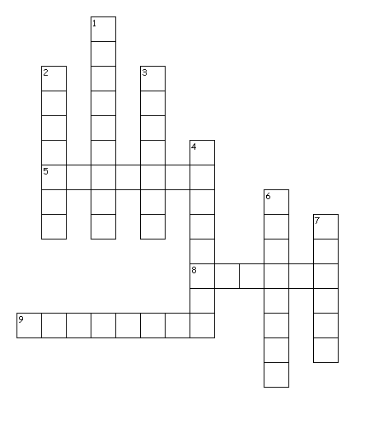
Across
5. - Disney world
8. - Red Socks
9. - City of Gambling
Down
1. - city of country music
2. - Yankees
3. - also the name of a bird
4. - Christopher...
6. - CT's capital
7. - very cold

Months
- Can be diagonal, across, horizontal and backwards

E F X J I S L D J N I N R K A
G C H Y A R E J C Z O O E C V
B Y N B C C U P S Q W V B W J
F Y T L E L B E T E M E O M Q
X H R M Y T Y A M E F M T F B
L B B A S U A O V K M E C W J
H E E U U G X M W I M B O Y U
R I G S C N Y F V S I E E J N
J U J Y D R A Y W R N R H R E
A M A R C H I J T W P U T B T
A B R G N Y U Z I W H C S A D
V P X O K I Y R A U R B E F P
F S R E C V U I P Q Q G U K N
H S X I Q I R U Q R X N Q G S
S L X R L N C A O O I N O V S

APRIL
AUGUST
DECEMBER
FEBRUARY
JANUARY
JULY
JUNE
MARCH
MAY
NOVEMEBER
OCTOBER
SEPTEMBER

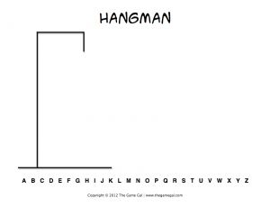

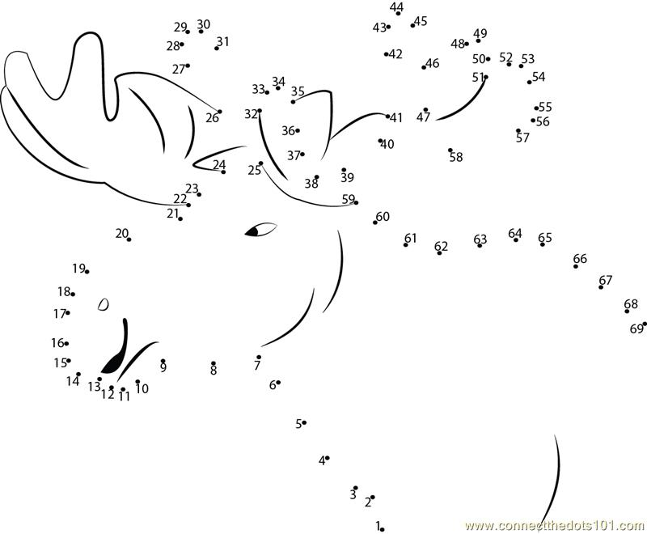

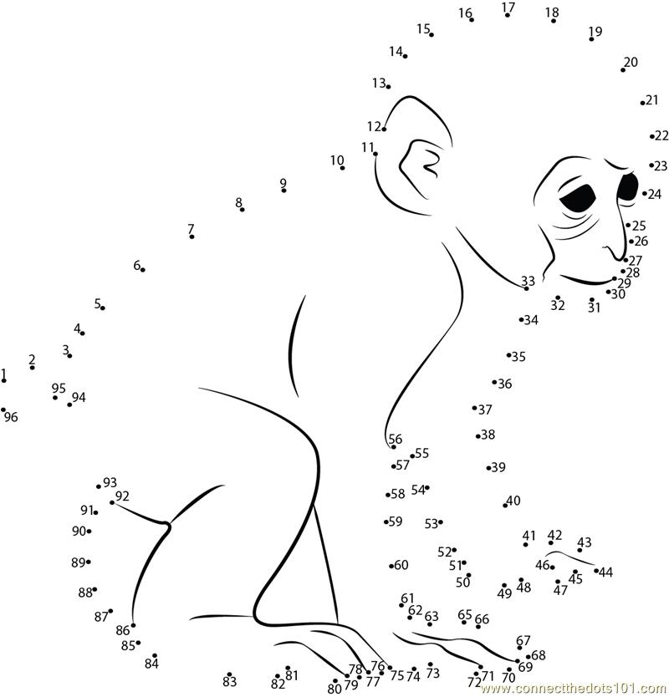

Color in the pictures
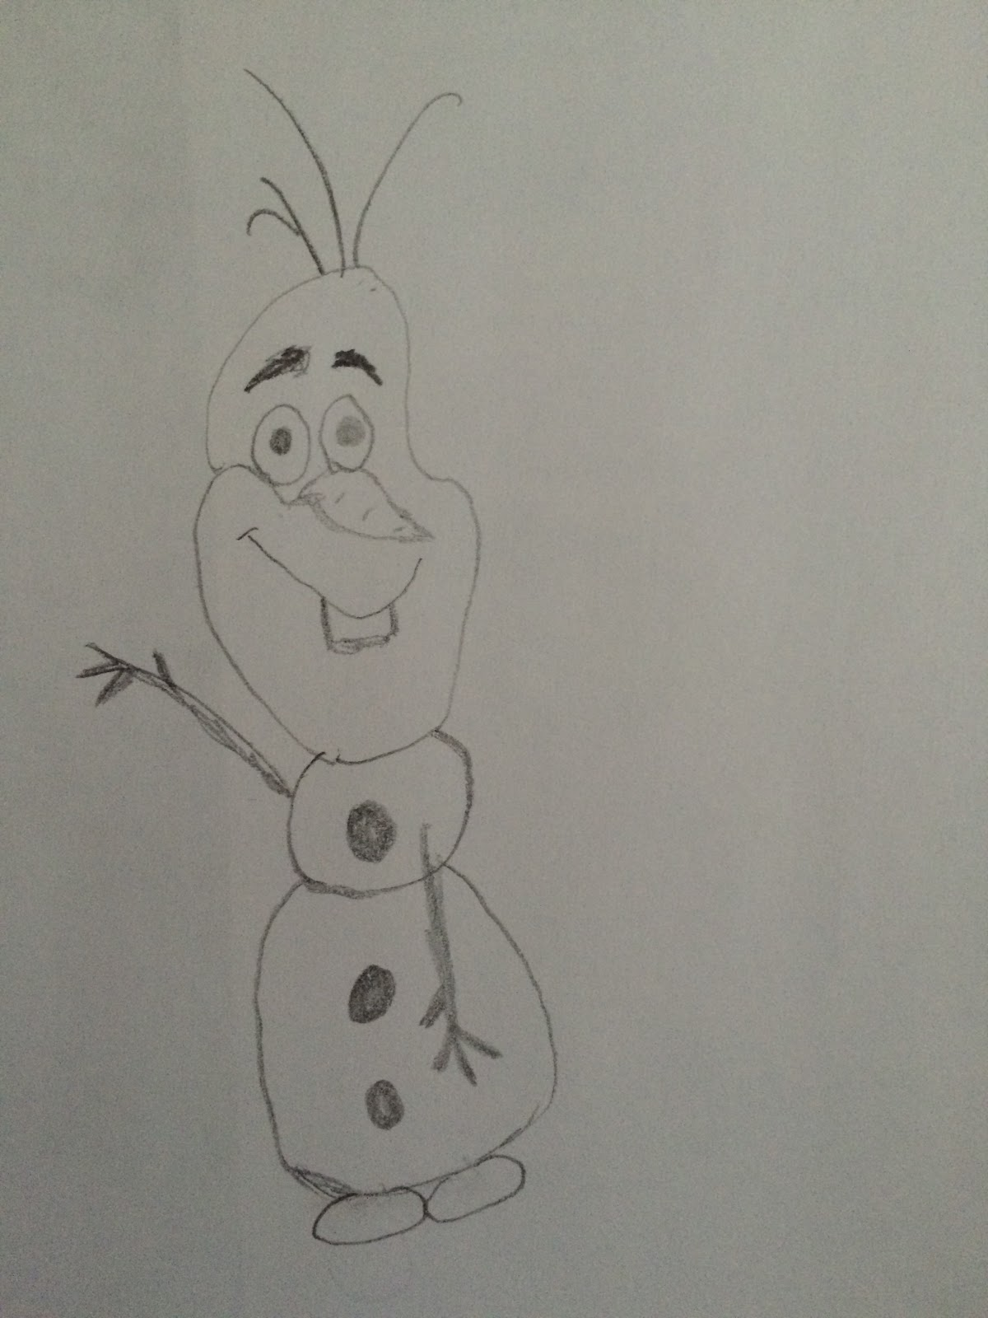

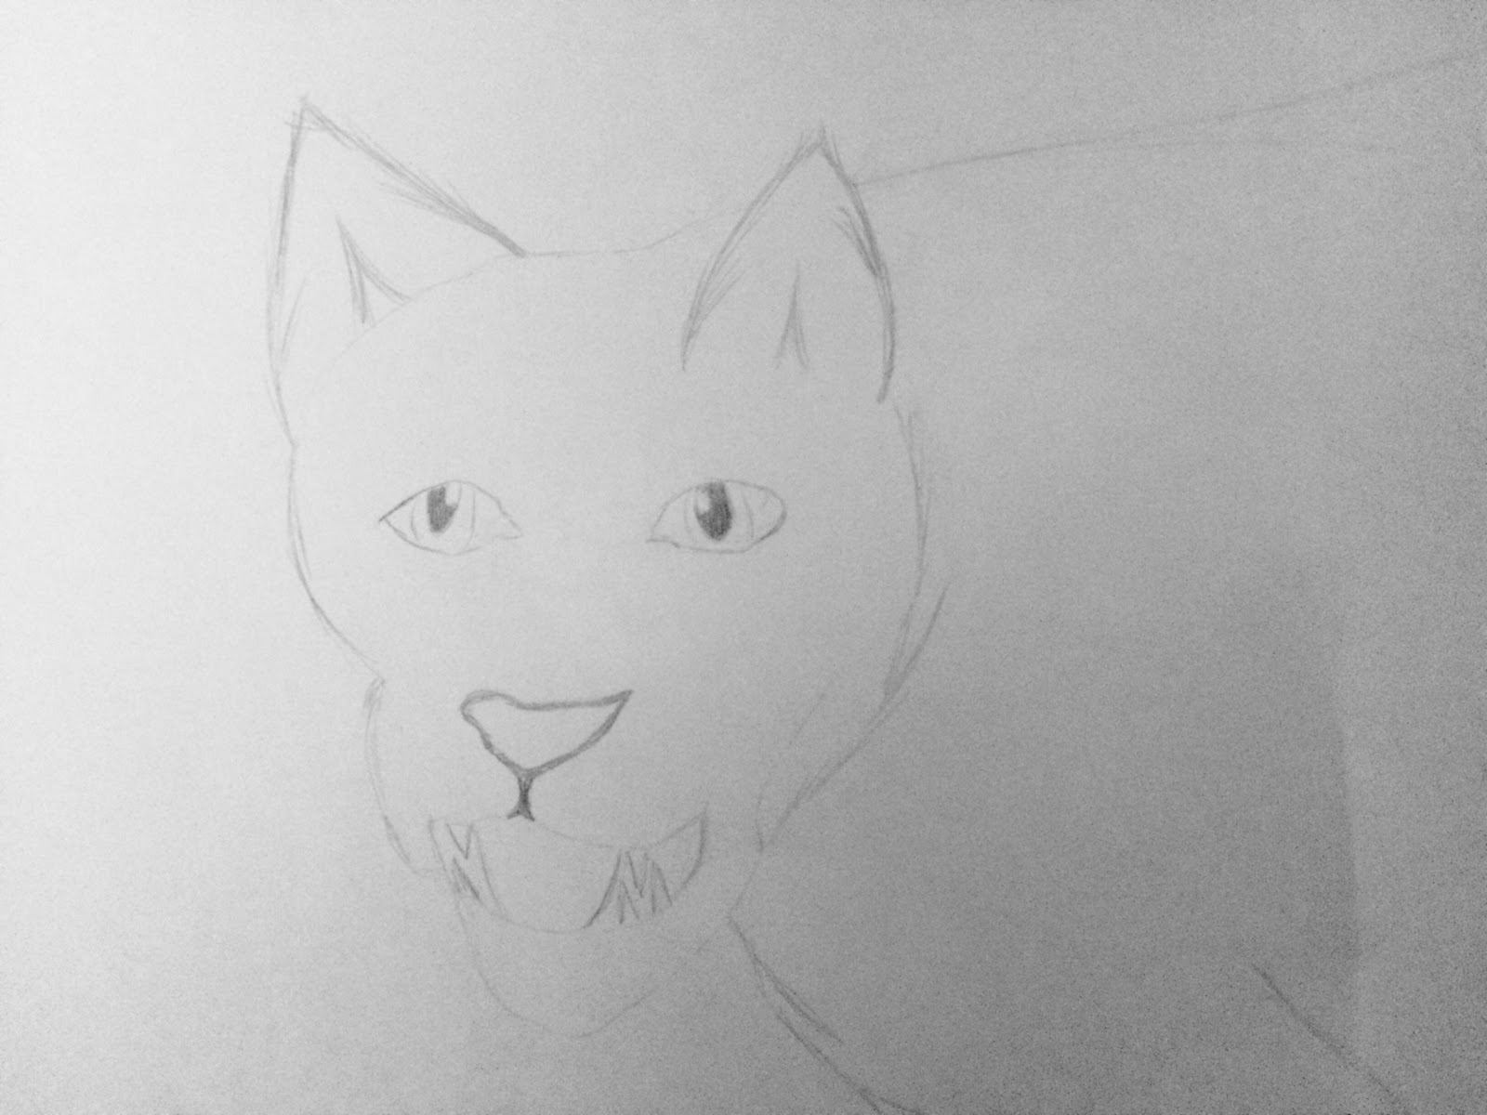
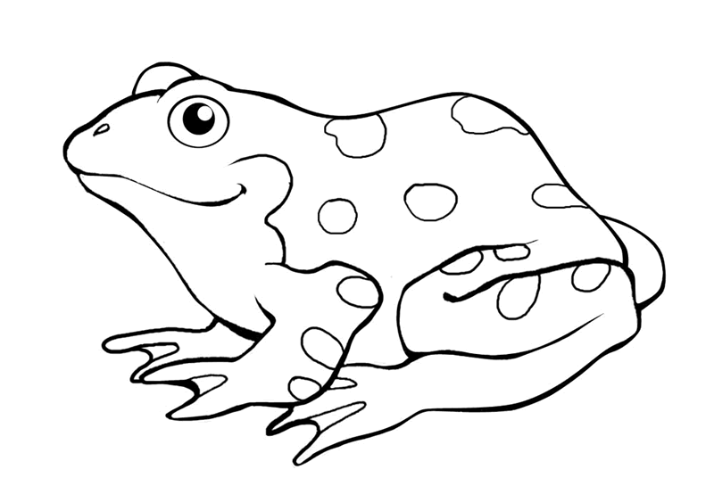

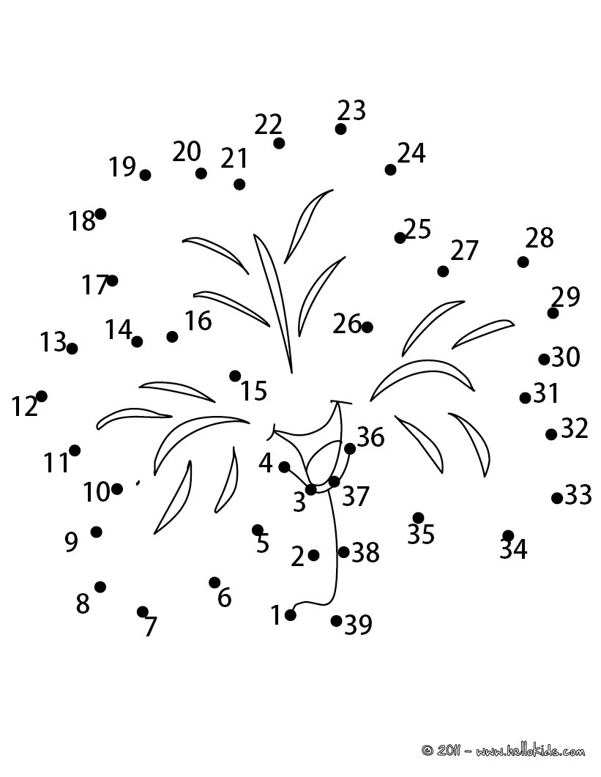

Line and Dot Game
Directions - This is a game for two or more people.
1. Start the game. Take turns drawing horizontal or vertical lines between adjacent dots connecting them together.
2. If you complete a full square, write your initial in the box and take another turn. If your line creates two boxes, then you get to put your initial in both of them. Some strategy will be involved to see if you can create more boxes than your opponent.
3. Continue playing until all the dots on the page are connected.
4. Count how many boxes each player has on the page. The player with the most boxes wins!
Here is an example of a game:

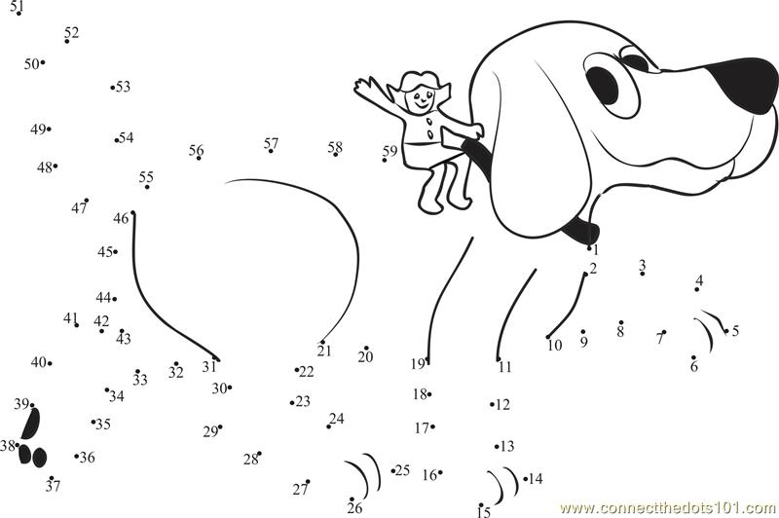
Tic Tac Toe Boards

States
- Can be diagonal, across, horizontal and backwards

O E M I C H I G A N Y S Z U K H D
A C B M J K M F M S S O A X T O U
B I A A P A L T G O W U M P B A E
Q B N D L O D U P H L T E V R J H
I M N R R A N A B F C H T V O O Q
H K N D O S B U V O X C A D I K K
F B I U B F H A N E F A A H K A Y
N A I O W A I N M P N R O H S E K
E W U O V B E L C A O O Y E A E U
W Q F T G C I P A L R L K I X S L
Y V H Y T Y F I O C D I L W E S F
O I O I R Q T C U X O N P M T E J
R V C N O T G N I H S A W X R N P
K U S A S N A K Q F T O Q X R N Z
T D M A X L B O S B X D T U I E G
J J M J T Q X O B F Y P Q M I T E
A E Y K K Y Y P L G C H D K J L Y

ALABAMA UTAH
CALIFORNIA WASHINGTON
COLORADO TEXAS
CONNECTICUT
FLORDIA
IOWA
KANSAS
MICHIGAN
NEVADA
NEWYORK
OHIO
SOUTHCAROLINA
TENNESSEE

Help me find the way out!
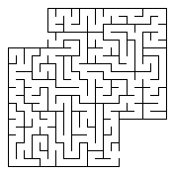

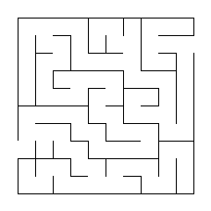

States answers
+ + M I C H I G A N + S + U + + +
A + + + + + + F + + + O + + T + +
+ I + A + A L + + + + U + + + A +
+ + N + L O D + + + + T + + + + H
+ + + R R A + A + + C H + + O O +
+ + + D O + B + V O + C + D I + +
+ + I + + F + A N E + A A H + + +
N A I O W A I N M + N R O + S E +
E + + + + + E L + A O O + + A E +
W + + + + C + + A L + L + + X S +
Y + + + T + + + O C + I + + E S +
O + + I + + + C + + + N + + T E +
R + C N O T G N I H S A W + + N +
K U S A S N A K + + + + + + + N +
T + + + + + + + + + + + + + + E +
+ + + + + + + + + + + + + + + T +
+ + + + + + + + + + + + + + + + +

Citys-
Nashville - city of country music
LasVegas - City of Gambling
Columbus - Christopher...
NewYork - Yankees
Boston - Red Socks
Phoenix - also the name of a bird
Hartford - CT's capital
Denver - very cold
Orlando - Disney world
Months answers
+ + + + + S + D + + + N R + +
+ + + + + + E J + + + O E + +
+ + + + + C U P + + + V B + +
+ Y + + E L + + T + + E O + +
+ + R M Y T Y A M E + M T + +
+ + B A S + + + + + M E C + J
+ E + U U + + + + + + B O + U
R + G + + N + + + + + E E + N
+ U + + + + A + + + + R + R E
A M A R C H + J + + + + + + +
A + + + + + + + + + + + + + +
+ P + + + + Y R A U R B E F +
+ + R + + + + + + + + + + + +
+ + + I + + + + + + + + + + +
+ + + + L + + + + + + + + + +

Dementia is an overall disease that occurs overtime in people, normally showing symptoms of memory loss around the age of 60. Sometimes early but the older you get the more severe your case may become. The most common form of dementia is Alzheimer’s which is when your ability to think, and remember things are slowly disintegrating. Often one’s ability to do a simple task alone is out of range as this irreversible disease is happening.
There are early signs and symptoms of dementia, the most common sign is memory loss, as well as issues speaking and communicating, problems focusing, judgement problems, and difficulty understanding what the person is seeing.
There are multiple stages of dementia starting with stage 1 – no problems. Stage 2 – there is little bit of difficulty with a patient but can function independently. Stage 3 – there are noticeable signs of impairment and has a few issues with daily activities. Stage 4 – there needs to be help caring for the person. Stage 5 – the patients are completely unable to do daily activities independently.
Different types of Dementia are Alzheimer’s disease, Vascular dementia, Dementia with Lewy bodies, Mixed dementia, Parkinson’s disease, Frontotemporal dementia, Creutzfeldt – Jakob disease, Normal pressure hydrophalus, Huntington’s disease, and Wernicke-Korsakoff Syndrome. (For more information on the different types of dementia, visit http://www.alz.org/dementia/types-of-dementia.asp)

If you know somebody who may have this problem, or are just looking for further information, feel free to contact specialists to help with more questions or concerns, (Any hospital or local doctors office should be available to help you as well if needed):
Alzheimer's Association - Connecticut Chapter - Southwest Regional Office - Norwalk | Giving Alzheimer's Purpose
Phone: 203-939-1360
Address: 607 Main Avenue Norwalk, CT 06851
Apple Rehab - Colchester | Closed Dementia Unit
Phone: 860-537-4606
Address: 36 Broadway Colchester, CT 06415
Brookdale South Windsor | Assisted Living - Memory Care
Phone: 860-644-4408
Address: 1715 Ellington Road South Windsor, CT 06074
Franciscan Ever There Care | In Home Assistance
Phone: 203-630-2881
Address: 273 Finch Avenue Meriden, CT 0645
Alzheimer's Association - Connecticut Chapter - Northwest Regional Office - New Milford | Early Stages/Early Stages Couples Group/Younger Onset
Phone: 800-272-3900
Address: 40 Main Street New Milford, CT 06776
Danbury Hospital - Neurology, Department of Medicine
24 Hospital Ave. Danbury, CT 06810
Call (203) 739-7000 to schedule an appointment or for general information.

Fun & Games
Part C

I created this book as part of my Gold Award Project. This is the highest award a girl scouts may earn. I thought dementia, and Alzheimer’s were important disease that many people do not know the effects of. Through my research I have found there are many different styles of this disease but they range in various stages, or symptoms. This activity booklet is to help prevent or postpone the major stages by keeping one’s mind active. Hopefully you will enjoy it!

Help me find the way out!
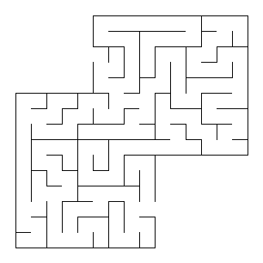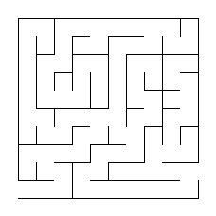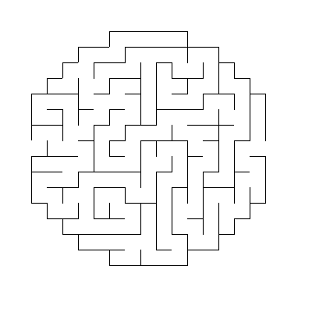

Help me find the way out!

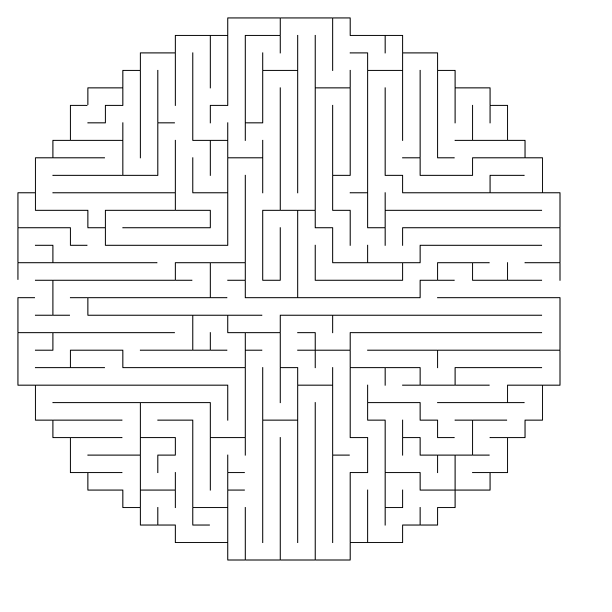

Colors

T K W V R S E A E B M N Y Q W
S E C P I U B Z L P I N K M O
V F L L D M N A G R E Y A Z L
H O V O A C C T T W N V Y K L
V E K W I K O N W O R B S X E
R B L U E V T G L L Q X B Q Y
E D M X R N O P I J O N T Q N
N G D E R E G U U D G G Y P G
J E N J F E G R N B N D R O W
K C T A F R M P E G N I L L W
R S N I R G Z L O R Z D M M W
S P I A H O N E W C K O H E F
L B T C D W C O F I E V H Y E

BLACK
BLUE
BROWN
GOLD
GREEN
GREY
INDIGO
ORANGE
PINK
PURPLE
RED
SILVER
VIOLET
WHITE
YELLOW

Art

I | K | J | P | V | U | S | C | O | K | R | T | H | H | S
M | M | U | C | S | N | R | N | W | Q | G | X | Y | W | I
L | G | A | P | L | E | P | G | O | D | I | E | O | Z | P
Z | N | D | G | A | A | K | C | Q | Y | W | I | H | K | J
J | T | P | T | I | S | R | E | K | R | A | M | K | D | T
W | U | I | N | H | N | T | H | U | J | Y | R | T | E | R
E | V | T | Y | P | B | A | E | S | L | K | L | C | R | A
E | R | E | P | A | P | G | T | L | N | G | F | I | O | P
C | P | M | K | L | P | S | I | I | S | X | T | I | L | I
O | H | N | X | E | L | Y | D | M | O | M | G | P | O | C
L | I | E | L | I | M | B | Q | T | R | N | K | Z | C | T
O | R | J | C | E | N | D | R | A | W | I | N | G | S | U
R | K | N | T | Y | M | G | Y | K | A | D | A | E | D | R
S | E | Y | N | H | E | W | T | R | Z | U | I | J | B | E
P | L | Y | Y | B | F | O | N | L | A | P | M | N | H | S

ART | COLORED | COLORS
CRAYONS | CREATIVE | DRAWING
GLUE | IMAGINATION | INK
MARKERS | PAINT | PAPER
PASTELS | PENCILS | PICTURES

Line and Dot Game
Directions - This is a game for two or more people.
1. Start the game. Take turns drawing horizontal or vertical lines between adjacent dots connecting them together.
2. If you complete a full square, write your initial in the box and take another turn. If your line creates two boxes, then you get to put your initial in both of them. Some strategy will be involved to see if you can create more boxes than your opponent.
3. Continue playing until all the dots on the page are connected.
4. Count how many boxes each player has on the page. The player with the most boxes wins!
Here is an example of a game:

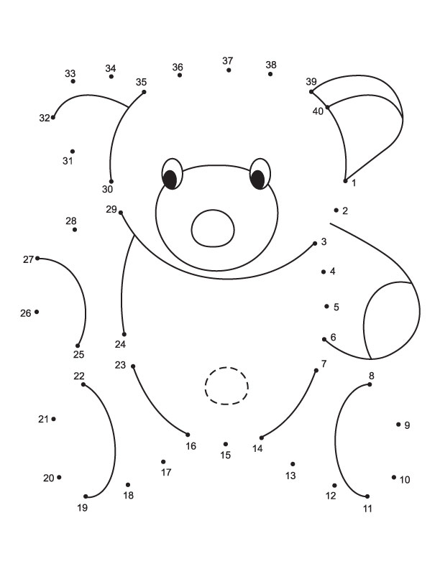

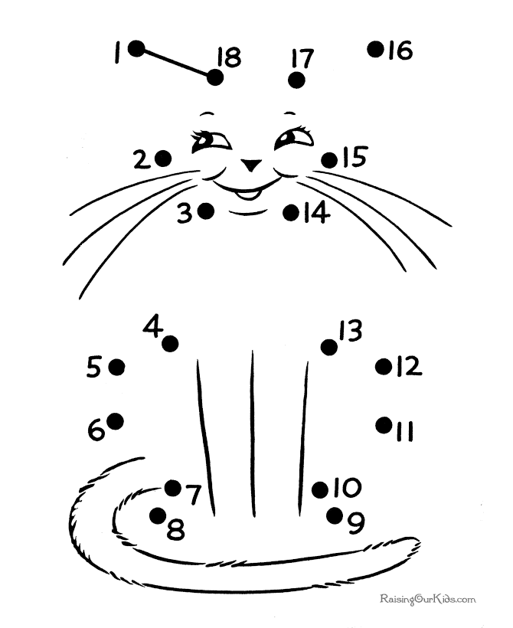

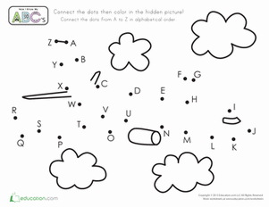

Help me find the way out!
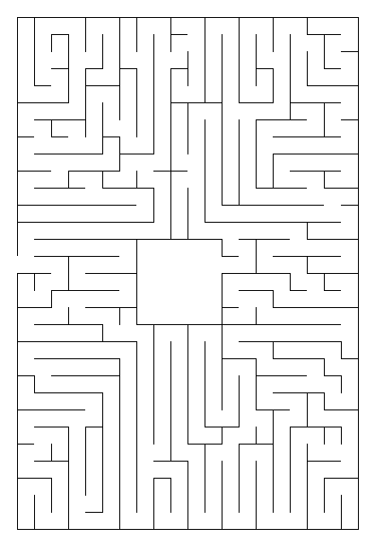

Tic Tac Toe Boards

Help me find the way out!
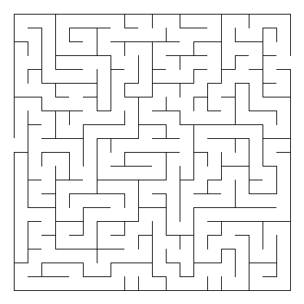

Help me find the way out!
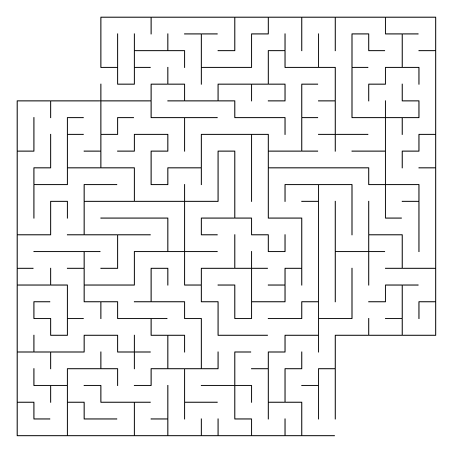

Color in the pictures
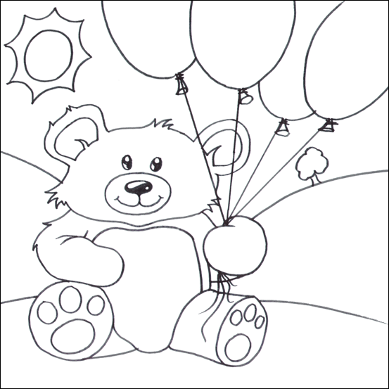

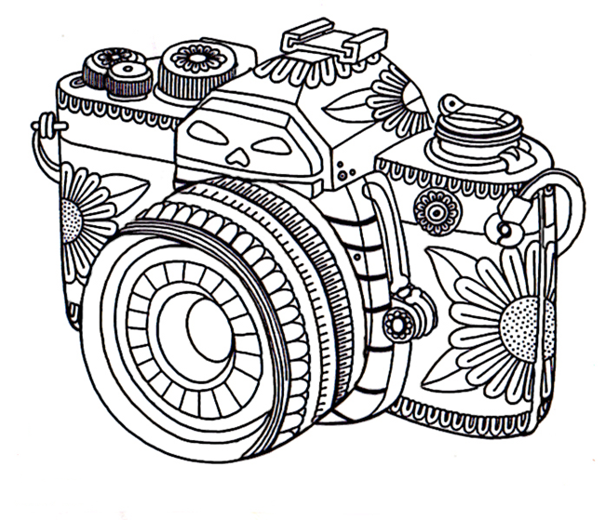

Solution art

Solution colors

T + + + + S + + + B + + + + W
+ E + + I + + + L P I N K + O
+ + L L + + + A G R E Y + + L
+ + V O + + C + + + + + + + L
+ E + + I K O N W O R B + + E
R B L U E V + G + + + + + + Y
E + + + + N + P I + + + + + +
+ G D E R E + U + D + + + + G
+ E N + + E + R + + N + + O +
+ + T A + R + P + + + I L + +
+ + + I R G + L + + + D + + +
+ + + + H O + E + + + + + + +
+ + + + + W + + + + + + + + +

(Over,Down,Direction)
BLACK(10,1,SW)
BLUE(2,6,E)
BROWN(12,5,W)
GOLD(15,8,SW)
GREEN(6,11,N)
GREY(9,3,E)
INDIGO(12,10,NW)
ORANGE(6,12,NW)
PINK(10,2,E)
PURPLE(8,7,S)
RED(5,8,W)
SILVER(6,1,SW)
VIOLET(6,6,NW)
WHITE(6,13,NW)
YELLOW(15,6,N)

I + + + + + S C + + + + + + +
+ M + + + + R N + + + + + + +
+ + A P + E P + O + + + + + +
+ + + G A A + + + Y + + + + +
+ + + T I S R E K R A M + D T
+ + I N + N T + U + + R + E R
+ V T + + + A E + L + + C R A
E R E P A P + T L + G + + O P
C + + K + + S + I S + + + L I
O + N + + L + + + O + + + O C
L I + + I + + + + + N + + C T
O + + C + + D R A W I N G + U
R + N + + + + + + + + + + + R
S E + + + + + + + + + + + + E
P + + + + + + + + + + + + + S

(Over,Down,Direction)
ART(15,7,N)
COLORED(14,11,N)
COLORS(1,9,S)
CRAYONS(13,7,NW)
CREATIVE(8,1,SW)
DRAWING(7,12,E)
GLUE(11,8,NW)
IMAGINATION(1,1,SE)
INK(2,11,NE)
MARKERS(12,5,W)
PAINT(7,3,SW)
PAPER(6,8,W)
PASTELS(4,3,SE)
PENCILS(1,15,NE)
PICTURES(15,8,S)

http://www.momsminivan.com/lines-and-dots-car-game.html
Dementia is an overall disease that occurs overtime in people, normally showing symptoms of memory loss around the age of 60. Sometimes early but the older you get the more severe your case may become. The most common form of dementia is Alzheimer’s which is when your ability to think, and remember things are slowly disintegrating. Often one’s ability to do a simple task alone is out of range as this irreversible disease is happening.
There are early signs and symptoms of dementia, the most common sign is memory loss, as well as issues speaking and communicating, problems focusing, judgement problems, and difficulty understanding what the person is seeing.
There are multiple stages of dementia starting with stage 1 – no problems. Stage 2 – there is little bit of difficulty with a patient but can function independently. Stage 3 – there are noticeable signs of impairment and has a few issues with daily activities. Stage 4 – there needs to be help caring for the person. Stage 5 – the patients are completely unable to do daily activities independently.
Different types of Dementia are Alzheimer’s disease, Vascular dementia, Dementia with Lewy bodies, Mixed dementia, Parkinson’s disease, Frontotemporal dementia, Creutzfeldt – Jakob disease, Normal pressure hydrophalus, Huntington’s disease, and Wernicke-Korsakoff Syndrome. (For more information on the different types of dementia, visit http://www.alz.org/dementia/types-of-dementia.asp)

If you know somebody who may have this problem, or are just looking for further information, feel free to contact specialists to help with more questions or concerns, (Any hospital or local doctors office should be available to help you as well if needed):
Alzheimer's Association - Connecticut Chapter - Southwest Regional Office - Norwalk | Giving Alzheimer's Purpose
Phone: 203-939-1360
Address: 607 Main Avenue Norwalk, CT 06851
Apple Rehab - Colchester | Closed Dementia Unit
Phone: 860-537-4606
Address: 36 Broadway Colchester, CT 06415
Brookdale South Windsor | Assisted Living - Memory Care
Phone: 860-644-4408
Address: 1715 Ellington Road South Windsor, CT 06074
Franciscan Ever There Care | In Home Assistance
Phone: 203-630-2881
Address: 273 Finch Avenue Meriden, CT 0645
Alzheimer's Association - Connecticut Chapter - Northwest Regional Office - New Milford | Early Stages/Early Stages Couples Group/Younger Onset
Phone: 800-272-3900
Address: 40 Main Street New Milford, CT 06776
Danbury Hospital - Neurology, Department of Medicine
24 Hospital Ave. Danbury, CT 06810
Call (203) 739-7000 to schedule an appointment or for general information.

