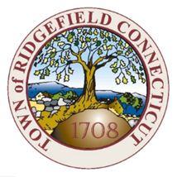

Town of Ridgefield
Board of Selectmen Meeting Motions
October 25, 2023 at 6:30pm
Please note – these minutes are not verbatim

Present: Rudy Marconi, Bob Hebert, Maureen Kozlark, Barbara Manners
Absent: Sean Connelly

Bob Hebert moved to approve all 2023 transfers submitted by Kevin Redmond, Director of Finance, Maureen Kozlark seconded the motion. Motion carried 4-0.
Maureen Kozlark moved to approve of sending all grants from Jake Muller to the Board of Finance for review and approval, Bob Hebert seconded the motion. Motion carried 4-0.
Bob Hebert moved to approve the Historic District's request for historic road signage in Ridgefield, and Maureen Kozlark seconded the motion. Motion carried 4-0.
Maureen Kozlark moved to approve the appointment of Will Knispel for the Youth Committee, Bob Hebert seconded the motion. Motion carried 4-0.
Bob Hebert moved to approve a five-year renewal for Rides for Ridgefield using Town Hall Space, and Maureen Kozlark seconded the motion. Motion carried 4-0.
Barbara Manners moved to approve of $9,478.86 in Tax Collector Refunds, Bob Hebert seconded the motion. Motion carried 4-0.
Maureen Kozlark motioned to adjourn the October 25, 2023 Board of Selectmen meeting, Bob Hebert seconded the motion. Motion carried 4-0. The meeting adjourned at 9:58 PM.

